1.Set up Windows Defender Firewall on your Windows laptop or PC and create a new inbound rule to block all incoming traffic on port 8080. Take a screenshot of the rule you created.
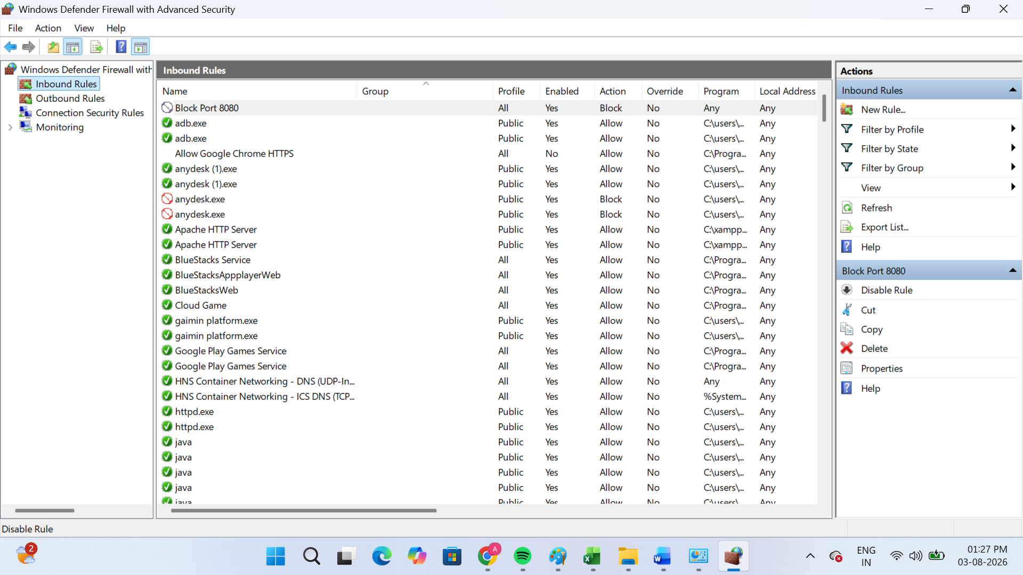
2.Simulate NAT (Network Address Translation) by drawing a simple diagram showing how your home WiFi router assigns private IP addresses to your phone, laptop, and smart TV, and how it translates them to a single public IP for internet access.<br><br><em><strong>Hint:</strong> Use any drawing tool or even hand-draw and click a photo.</em>
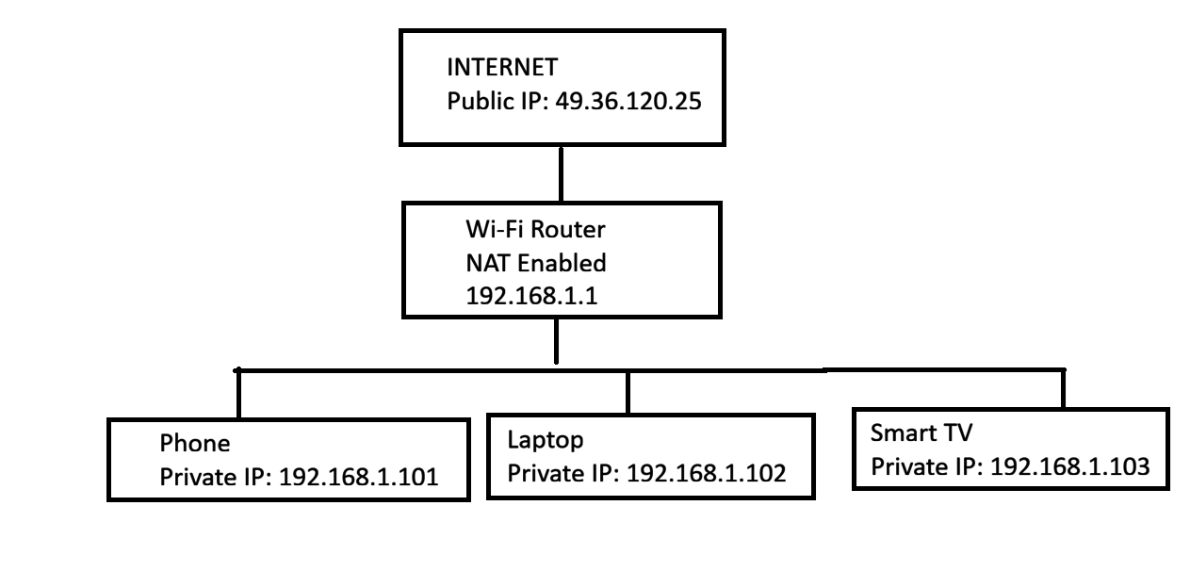
3.Configure port filtering using your WiFi router's admin panel (or use a router simulator online if you don't have access). Block outgoing traffic on port 25 (SMTP) and explain in 2 sentences how this could help prevent spam from your network.
Steps to Configure Port Filtering (Block Port 25 - SMTP)
- Open a web browser and enter the router's IP address (e.g., 192.168.1.1).
- Log in to the router's admin panel using the administrator username and password.
- Go to Security, Firewall, or Access Control settings (the name may vary by router model).
- Open the Port Filtering or Outbound Rules section.
- Create a New Rule with the following settings:
- Protocol: TCP
- Port: 25
- Direction: Outbound
- Action: Block / Deny
- Save or Apply the settings.
- Restart the router if required.
Example Rule
Setting | Value
Rule Name | Block SMTP
Protocol | TCP
Port Number | 25
Direction | Outbound
Action | Block

- Blocking outgoing traffic on port 25 (SMTP) helps prevent infected devices from sending spam emails directly through the internet. This reduces the risk of your network being misused for spam or malicious email activity.
4.Given a sample packet filtering rule set (provided by your trainer), identify which of these three sample packets would be allowed or blocked: 1) HTTP request from 192.168.1.5 to 172.217.166.78:80, 2) SSH request from 10.0.0.10 to 34.201.23.1:22, 3) DNS query from 192.168.1.7 to 8.8.8.8:53.<br><br><em><strong>Hint:</strong> Focus on source/destination IPs and ports in the rule set.</em>
Sample Packet | Result | Reason
HTTP request from 192.168.1.5 to 172.217.166.78:80 | Allowed | HTTP uses port 80, which is normally allowed.
SSH request from 10.0.0.10 to 34.201.23.1:22 | Blocked | SSH uses port 22, which is often blocked by firewall rules for security.
DNS query from 192.168.1.7 to 8.8.8.8:53 | Allowed | DNS uses port 53, which is required for domain name resolution.

5.Research and list 3 ways Instagram or Zomato might use firewalls and packet filtering to protect their servers from attacks or misuse.
->3 Ways Instagram or Zomato Use Firewalls and Packet Filtering
- Block Unauthorized Access
- Firewalls block unauthorized users and hackers from accessing company servers.
- Only trusted network traffic is allowed.
- Protect Against DDoS Attacks
- Packet filtering detects and blocks suspicious or excessive traffic.
- This helps keep Instagram or Zomato websites and apps available during attacks.
- Allow Only Required Services
- Firewalls allow only necessary ports (such as HTTPS - Port 443) and block unnecessary ports.
- This reduces security risks and prevents misuse of the servers.

